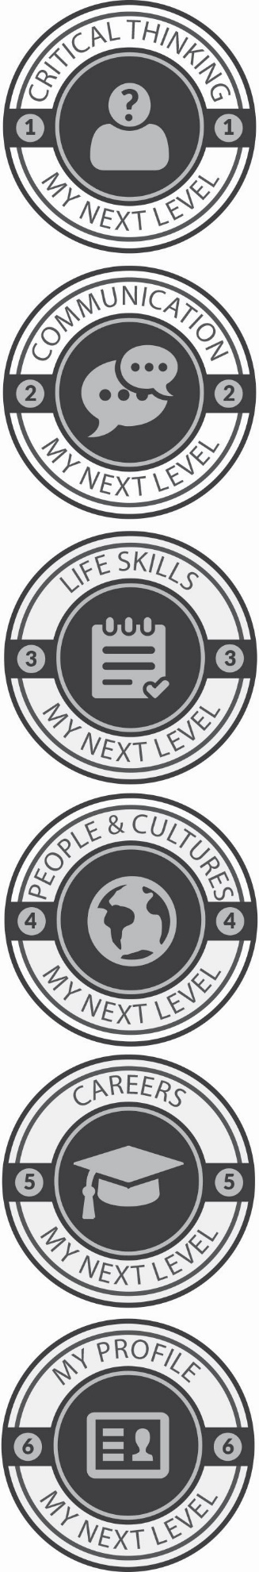

January 1st, 2020

Dear Caregivers,

This school year, students in [Program Name] will be participating in a program called “My Next Level.” Over the course of the year, students will complete six different levels with different themes by completing different tasks and activities. These levels and activities are designed to help students build skills they will need as an adult and in their future careers. Some of the activities include learning how to complete household chores, improving communication skills, learning about family history and traditions, and thinking about the world around them. Some of these activities will be done as a group in the program, some of the activities will be done individually or in small groups, and some of the activities are made to be done with an adult at home. At the end of the year, students will participate in a final show to demonstrate their work in the program. If you have any questions or concerns about your child’s work, please feel free to contact me or your child’s instructor.

Thank you!

[Administrator Name]
[Administrator Title]

